UX DESIGN 30064801’S REPORT
Tittle: FoodTales
Main HTML file: home.html
StudentID: 30064801
Section 1 - Concept & target users
What is the website core concept?
My website concept is a global culinary storytelling platform dedicated to exploring the world’s cuisines through personal experiences and cultural narratives rather than reviews or opinions. While food has been celebrated worldwide, there remain countless untold stories behind the dishes, the memories, traditions, and emotions that give them meaning.
What is the website purpose?
A community blog where people can share their own food stories and recipes, from cherished childhood meals and family recipes passed down through generations, to local legends and cultural origins of beloved dishes.
My website will serve as a living archive of global culinary culture, preserving not only recipes but also the emotions, history, and myths that breathe life into every dish. Users will be able to contribute their own stories, photos, and memories, and explore the deep cultural roots and folklore that connect people across countries, generations, and traditions.
Why is this a good / strong design concept?
Personally, I think this is a strong design concept because it offers a unique perspective on food. Most websites emphasize reviews or recipes without the real soul, the emotion in the foods. My website will goes beyond those recipes or restaurant reviews to focus on the human stories and emotions that give each dish meaning from all around the world. By highlighting personal memories, cultural traditions, and local legends, the website turns food into a vessel for storytelling and cultural preservation. It invites people from around the world to share their own experiences, creating a rich, community based archive that celebrates both diversity and connection. Through shared stories and recipes, users can explore how food shapes identity, brings people together, and carries history across generations.
Who is it aimed at?
My website is aimed at anyone who sees food as more than just nourishment but food enthusiasts, home cooks, travelers, researchers, and families who want to share their culinary heritage. It also appeals to people who are curious about global cultures, those who wish to reconnect with their roots, and anyone who believes that behind every dish lies a story worth telling.
Persona Insight
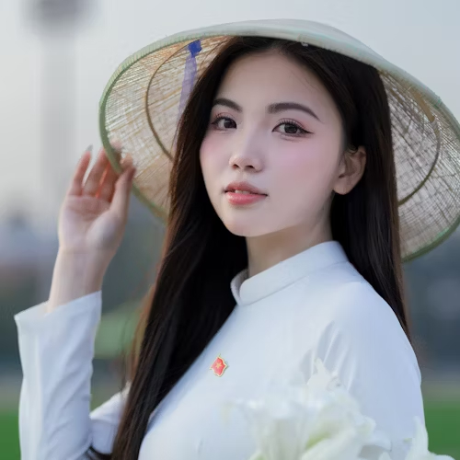
Phuong, 21 years old, born in Ha Noi and now studying abroad.
Name: Phuong
Age: 21 years old
Location: Australia
Background: Vietnamese expatriate with strong emotional ties to her cultural and culinary heritage
Goals: Preserve family recipes; share cultural stories; connect with others who feel homesick.
Needs: An easy posting interface, photo upload, “related memory” section; comment and community features.
Pain Points: Fear of losing family traditions; limited authentic food experiences; lack of suitable platforms.
Desired Outcomes: A warm, shared archive for recipes and memories and intergenerational engagement, stronger cultural identity.
Quote: “I want our family recipes and memories to live on, even far from home.”

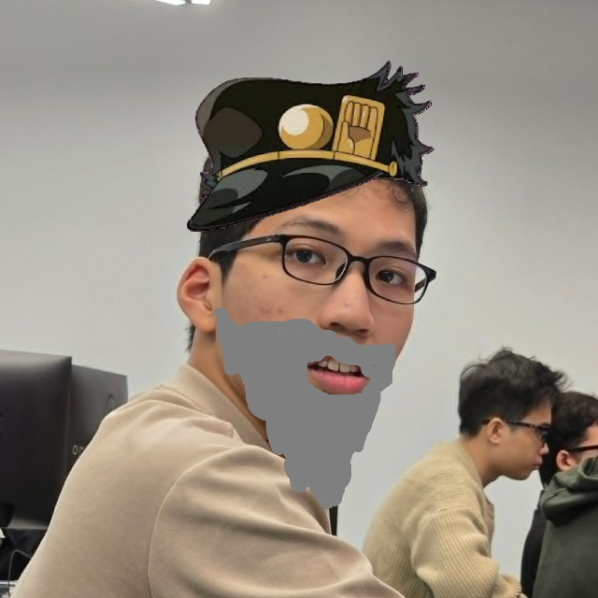
Dung Joestar, 52 years old, food and travel blogger, culturally curious.
Name: Dung Joestar
Age: 52 years old
Location: Frequent traveler (based internationally)
Background: A travel enthusiast and food writer passionate about exploring local cuisines and the cultural stories behind them.
Goals: Discover and document authentic food experiences, share cultural and historical contexts of dishes; provide accessible recipes for global readers.
Needs: Access to culturally rich posts; tagging by region or dish type; ability to upload articles with recipes, “save collection” feature to organize related stories.
Pain Points: Difficulty finding reliable sources that blend storytelling and recipes; challenges organizing diverse cultural materials, limited tools for curating thematic content.
Desired Outcomes: Build a curated collection of authentic food stories, engage readers through cultural insight, promote deeper appreciation of global cuisines.
Quote: “Every dish tells a story. I want readers to taste both the flavor and the history behind it.”

Phuong represents the memory keepers and family storytellers, the people with deep emotional connections to food and strong motivation to preserve and share their culinary heritage. Marco represents the curious consumers and cultural sharers users who explore, curate, and spread stories to wider audiences, transforming food narratives into accessible cultural experiences. Together, these personas capture both sides of the community dynamic: the contributors who provide authentic content and the explorers who seek, interpret, and share it.

Section 2 – Design Development
Details of how you have developed the initial concept into a complete design
The idea first came to me when I was talking with my friends about how food has changed compared to the old days. We started talking about all the amazing dishes our families used to make, and it brought back so many good memories. I had such a great time during that conversation, and it made me realize that there must be lots of people out there with similar stories they’d love to share. That’s when it hit me: why not create a global platform where everyone can share their own food stories and memories. Although cuisine has been widely celebrated online, countless stories remain untold, memories, traditions, and emotions deeply tied to each dish.
Choices of User Interface and interaction features
After researching several websites about cuisine, I decided to focus on a food storytelling platform that highlights experiences and memories in different cultures dishes. To facilitate user engagement, I included a “Forum” feature, which allows users to view discussions, share their own experiences, upload pictures, and describe their experieces, the dishes in the “Create Post” section. Additionally, the platform includes a “Home” page that serves as a landing page where users can explore featured stories. Clicking on a story triggers an interactive design element that displays a small post review, with a view more, on click will redirect to “Post View” pages, allow users to react with the post, share their thought on the post. I also added an “About Us” page to inform users about the purpose and goals of the website.
Details of the design of your entire application, including wireframes and or mock-ups of major screen layouts, and a navigation (sitemap) map showing how these interconnect.
My first attempt was to create a mocks up to visualize the website layout.
“Home” and “Forum” page’s mocks up.
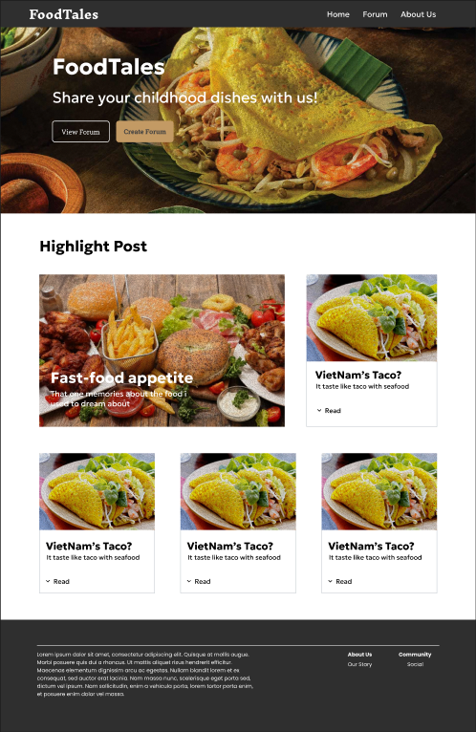 | 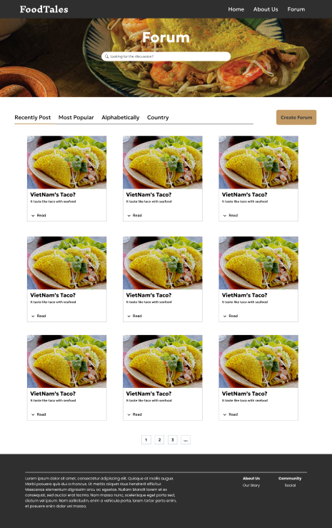

“Create Post” and “About Us” page’s mocks up.

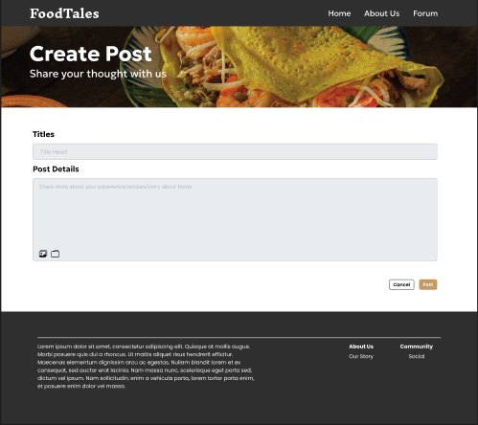
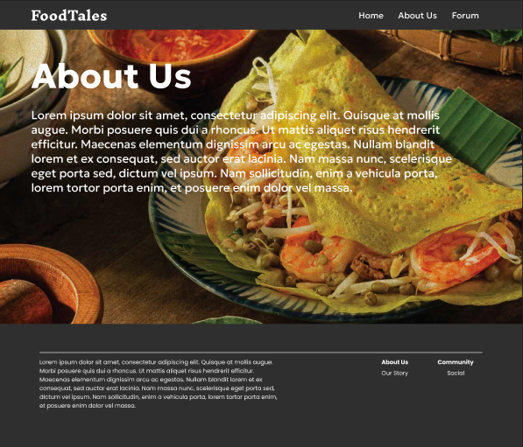

“Post View” page’s mocks up.
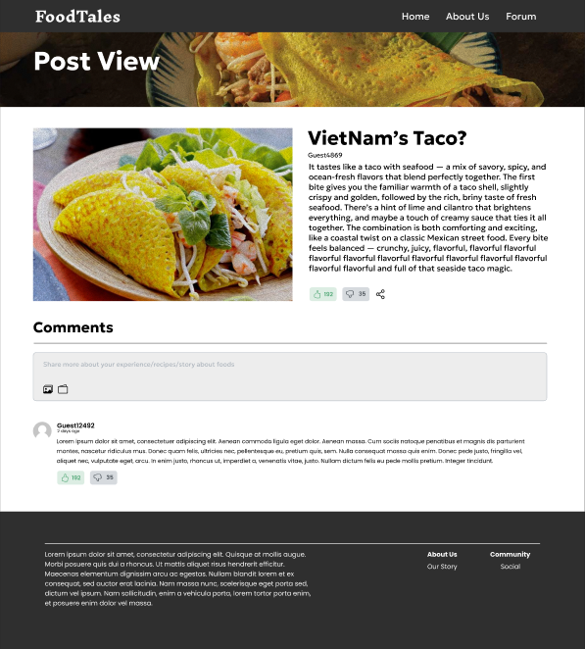
Additionally, I create a site map to provide a clearer and more structured organization of the content.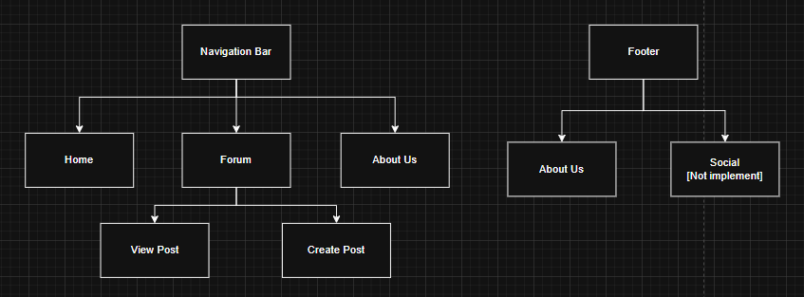

Thoroughly justify your design choices.
As shown in the previous pages, I made my own choices regarding font-size, font-family, and color theme. I also planned specific adjustments to the placement of certain buttons to improve the layout. It can also be noticed that the “Home” page appears somewhat incomplete and lacks sufficient content to achieve a balanced presentation.
First of all, the font-size and font-family. I used Geologica and Roboto Slab to bring a vibrant feelings and welcoming atmosphere that feels contemporary and stylish, while avoiding an overly traditional appearance.
For the color theme, I was inspired by fall-color palette, which include “Antique Brass” color and “Light Grey”. This combination was chosen to bring a sense of warmth and comfort, creating an inviting atmosphere that encourages users to share their thoughts openly and without hesitation. Initially, the navigation bar was designed to be invisible in order to create a more intimate and seamless user experience. However, since the text color blended with the background, this approach reduced readability and usability. herefore, alternative design solutions need to be implement so I choose the “Light Grey” color to be navigation bar background.
How does your design satisfy the needs of your personas and scenarios?
To bring our personas a simple and user-friendly interface suitable for users of all ages, the “Create Post” and “View Post” features are prominently displayed in the hero section of the landing page upon entering the website.
Further down the page, the post visuals and text elements are intentionally structured with larger images, a minimalist design approach, and text layouts that enhance the storytelling and emotional engagement of the content. This design approach provides users with a clearer understanding of the post’s content and overall web content.
On the “Forum” page, a search bar is positioned at the top, accompanied by a filter bar located beneath it. This design allow users to search for content efficiently and refine their results according to specific needs. At the bottom of the page, just above the footer, there is a pagination bar that allows users to explore additional related content.
The “Post View” page enables users to engage with the content by expressing positive or negative reactions through the “Like” and “Dislike” buttons, as well as by sharing their thoughts in the comments section.
The “Create Post” page is designed with a prominent title field and a large content section for user input. Additionally, it includes options to upload an image or select a video to accompany the post, can be easily seen and interact by user’s.
Lastly, the “About Us” page features prominently displayed text that informs users about how the website operates and the services it provides.
Section 3 – Usability Testing & Evaluation

